SCTIMST ties up with Wipro 3D to manufacture automated ventilators to meet COVID 19 related crisis

Sree Chitra Tirunal Institute for Medical Sciences and Technology (SCTIMST), an institute of National Importance of the Department of Science and Technology, has tied up with Wipro 3D, Bengaluru to jointly build up on a prototype of an emergency ventilator system based on Artificial Manual Breathing Unit (AMBU), developed by SCTIMST followed by its clinical trial and manufacture.
The ventilators can help meet urgent requirements arising out of the Covid 19 related crisis that the country is facing. AMBU bag or a bag-valve-mask (BVM) is a hand-held device used to provide positive pressure ventilation to a patient who is either not breathing or who is breathing inadequately. However, the use of a regular AMBU needs a bystander for its operations who is highly susceptible and non-advisable to be in close contact with the COVID-19 patient. Sree Chitra's Automated AMBU Ventilator with inputs from clinical faculty will assist the breathing of the critical patients who have no access to ICU ventilators.
For enabling rapid production, the device is designed with readily available components so that it becomes an alternative solution. It provides ventilation support to the needy and is an ideal solution for ventilation shortages.
This portable and lightweight device enables positive pressure ventilation with a controlled rate of expiration, Inspiratory to Expiratory Ratio, Tidal Volume, and so on. Also, A PEEP (Positive End Expiratory Pressure) Valve can be added as an extra component to maintain pressure on the lower airways at the end of the breathing cycle, which prevents the alveoli from collapsing during expiration. The compressed gas source can also be attached to the system. The automatic device will minimize the need of support personnel in the isolation room, thereby enabling a safer and effective lung-protective operation to COVID patients.

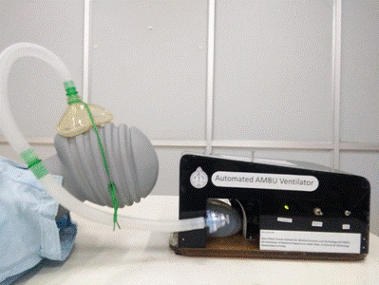

Dr. Asha Kishore, Director, SCTIMST, said, “The technology was developed in a week. Millions of people worldwide are affected by COVID-19, and the numbers are increasing at a very fast rate. In this alarming situation, a handy artificial manual breathing unit (AMBU) will be very helpful. SCTIMST has a long tradition of developing and commercializing need-based medical devices. We have risen to the occasion this time too.”

“Wipro 3D responded to the Expression of Interest (EoI) invited by Sree Chitra. We held an elaborate discussion with technical teams and assessed the prototype. We intend to quickly move into clinical trials and then and manufacturing through Wipro3D Bangalore,” she added.

The tie-up involved joint further improvements and developments, clinical trials, and production. This agreement was executed on fast track mode with the genuine intention of both parties to collaborate and offer support to the nation in the prevailing situation of COVID 19 pandemic. The Institute involved a cross-departmental team in developing the know-how and was led by Mr Sarath, Mr. Nagesh, Mr Vinod Kumar and personnel from the Artificial Organs Division, the Biomedical Technology Wing and Department of Anaesthesia of the Hospital.

{For more details please contact: Ms. Swapna Vamadevan, PRO, SCTIMST, Mob: 9656815943, Email: pro@sctimst.ac.in}

Source

Press Information Bureau, 02 April, 2020

