Agra-based company bags NRDC license for manufacturing NavRakshak PPEs

The National Research Development Cooperation (NRDC) has signed a technology licensing agreement for the manufacturing know-how of a PPE Suit named NavRakshak with an Agra-based apparel manufacturing entity, the Indian Garment Company. This company is also a registered micro enterprise under the Ministry of Micro, Small and Medium Enterprises (MSME) Act. The entity is already manufacturing PPE kits in and around Agra and supplying to various hospitals and has now proposed an annual production target of over one million PPE kits using the licensed know-how of NavRakshak to meet the increased requirement of PPEs enforced by COVID crisis.
NavRakshak PPE has been developed principally by Dr. Arnab Ghosh, a Naval Doctor. Dr Ghosh has incorporated his personal experiences in using the PPE for the comfort and protection of the doctors. It incorporates superior quality breathable fabric to make the PPE suit while its design innovation eliminates the need of costly taping and sealing of the seam which is otherwise needed in other PPEs available in the market. The fabric, suit and seam have been found to meet the synthetic blood penetration resistance criteria comfortably.
The prototype development took place earlier at the Naval Dockyard, Mumbai, and it was tested and certified at the Institute of Nuclear Medicine & Allied Sciences (INMAS), Defence Research and Development Organisation (DRDO) , an accredited lab authorized by the Ministry of Textile for PPE prototype sample testing as per the prevailing ISO standards and guidelines of the Ministry of Health and Family Welfare and the Ministry of Textile.

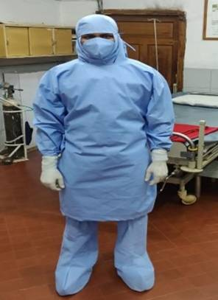

Source
Press Information Bureau, 27 June, 2020

