CSIR celebrates 20 years of India’s Traditional Knowledge Digital Library, the first of its kind globally
The Council of Scientific and Industrial Research (CSIR) has launched a new campaign of highlighting 80 success stories from the organization as it is set to turn 80 years old in 2022. This campaign was launched recently as CSIR’s Traditional Knowledge Digital Library (TKDL) completes two decades of safeguarding India’s Traditional Knowledge. To commemorate the two decades’ journey, a webinar “Two Decades of TKDL - Connecting to the Future" was organized. The distinguished dignitaries who graced the program were Dr. Raghunath A. Mashelkar, Former DG, CSIR & Secretary, DSIR;Vd. Rajesh Kotecha, Secretary, Min of AYUSH; Shri Guruprasad Mohapatra, Secretary, DPIIT and Ms. BegonaVenero, Sr. Counsellor, Traditional Knowledge Division, WIPO, Geneva, and Dr. Shekhar C. Mande, DG, CSIR and Secretary, DSIR.

Dr Viswajanani J Sattigeri, Head TKDL described the journey and highlighted that in 2001, CSIR jointly with Department of Indian Systems of Medicine & Homeopathy (ISM&H, now Ministry of Ayurveda, Yoga & Naturopathy, Unani, Siddha, Sowa Rigpa and Homoeopathy (AYUSH) developed the Traditional Knowledge Digital Library (TKDL). This initiative was a follow up action to thwart misappropriation of India’s valuable traditional knowledge, based on learnings from the patent battles with international patent offices over the grant of intellectual property rights on turmeric, neem, basmati rice and other such ancient knowledge and practices of the country. TKDL database contains more than 3.9 lakh formulations/ practices from the Indian systems of medicine (Ayurveda, Siddha, Unani and Sowa Rigpa) and Yoga. The database is available to only patent examiners through TKDL Access (Non-disclosure) Agreement and so far, Access Agreements have been signed with 13 international patent offices including India. Significantly, 239 patent applications have either been set aside/ withdrawn/ amended, based on the prior art evidences present in the TKDL database. The valuable partnership with Ministry of Ayush and DPIIT and support from WIPO were acknowledged.

Dr R.A. Mashelkar emphasized that TKDL should aim to promote traditional knowledge and emerge as a global repository, apart from safeguarding the information from misappropriation. Over the years, TKDL has grown in strength and is now poised to expand its scope. It envisages covering information from traditional knowledge such as disease diagnostics, veterinary medicine, agricultural practices, food, cosmetics, metallurgy, etc. and Traditional Cultural Expressions (TCE) such as architecture, metallurgy, paintings, carvings, textiles, etc. Going forward, the information from digitized and published manuscripts as well as oral knowledge is also proposed to be included in the TKDL database.
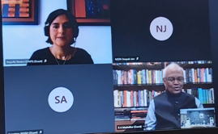 | 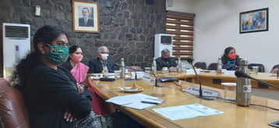

Source
Press Information Bureau, 29 January, 2021

