International Science Film Festival of India comes to a close
IISF-2020
A total of 20 films have bagged awards at the International Science Film Festival of India (ISFFI) 2020, which was held as part of the sixth India International Science Festival 2020 held from December 22-25. Six films bagged the awards for the international categories and 14 for the national categories.
In the international categories, the award winners include a film in English titled `The Insect Rescuer’, produced by ZDF and directed by Andreas Ewels of Germany (Best of Festival Award on the theme “Science for self-reliant India and/or Science for global welfare”); and a film in Persian titled `Night Nurse’ produced by Hasan Rahmani and directed by Ashkan Hatami of Iran (Best of Festival Award on the theme “Science and awareness on COVID-19 and other health emergencies”).
The other winners in foreign categories are: a film in English titled `A natural code’, produced and directed by Cristina Ceuca of U.K.; a film in English titled `iRony’, produced by Radheya Jegatheva and Jay Jay Jegathesan and directed by Radheya Jegatheva of Australia; and a film with no dialogue titled `Keep Your Smile’ produced and directed by Hassan Mokhtari of Iran (Jury Awards) and a film in Italian titled `Chemical Industries vs COVID-19’ produced and directed by Vittorio Caratozzolo & Class 3 A (Jury Special Mention).
The awards for Indian films were presented under two classifications - Independent filmmakers and college/school students.
The winners among Independent filmmakers include a film in English titled `The Trials and Triumphs of G.N.Ramachandran’ produced by Vivek Kannadi and directed by Rahul Iyer (Best of Festival Award in the theme “Science for self-reliant India and/or Science for global welfare”), a film in Hindi titled `Raja, Rani aur Virus’ produced by Beacon Television and directed by Seema Muralidhara (Best of Festival Award in the theme “Science and awareness on COVID-19 and other health emergencies”).
Among other winners, a film in Malayalam titled `Return of The Holy Grain’, produced and directed by G.S.Unnikrishnan Nair; a film in English titled `Worth Their Salt’ produced by Vigyan Prasar and directed by Seema Muralidhara and H.B.Muralidhara; a film in English titled `Humans vs Corona’ produced and directed by Anshul Sinha; and a film with no dialogue titled `My Mom’ produced by Dark Room Studio and directed by Rakesh Moirangthem, bagged the Jury Awards.
Besides, a film in Tamil titled `If Everybody be like this...!’ produced and directed by Rajkumar; a film in English titled `Mangroves: Nature’s Hardy Foot Soldiers’ produced by Educational Multimedia Research Centre, Calicut and directed by Sajeed Naduthody; and a film in Malayalam titled `The Cheruvayal Raman Effect’ produced and directed by G.S.Unnikrishnan Nair got `Jury Special Mention’.
The winners among college/school students include a film in English titled ` Croaking Frogs’ produced and directed by Aditya and a film in Hindi titled `Catching The Sun’ produced by Nilambar Pathak and Karunesh Singh and directed by Rahul Kumar (Best of Festival Award on the theme “Science for self-reliant India and/or Science for global welfare”); a film in Hindi titled `Can Break Cancer’ produced and directed by Neelu Sharma (Best of Festival Award on the theme “Science and awareness on COVID-19 and other health emergencies”) and a film in Hindi titled `Mask’ produced and directed by Santu Kumar and a film in English titled `Corona At Doorstep’ produced by Raghul M.R. and directed by Moumita Mazumdar (Jury Awards).
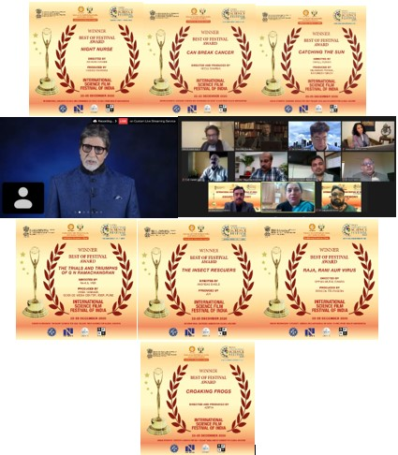

Source
Press Information Bureau, 25 December, 2020

