IUSSTF boosts Indo-US virtual networks to address COVID 19 challenges
The Indo-U.S. Science and Technology Forum (IUSSTF), has invited Proposals for ‘COVID-19 Indo-U.S. Virtual Networks’ that would allow Indian and U.S. scientists and engineers currently engaged in COVID-related research to carry out joint research activities through a virtual mechanism, leveraging existing infrastructure and funding. Proposals that convincingly demonstrate the benefits and value of the Indo-U.S. partnership to advance research and address critical challenges related to COVID-19 are encouraged.
Global challenges like COVID 19 call for global collaborations and partnerships, bringing together the best and brightest scientists, engineers, and entrepreneurs to work together to find solutions not only to address the current pandemic but also for the challenges that lie ahead. The IUSSFT is booting such collaborations for this specific purpose in keeping with their core mandate to catalyze collaborative initiatives across both countries.

The IUSSTF established under an agreement between the Governments of India and the United States of America in March 2000 is an autonomous bilateral organization jointly funded by both the Governments that promotes Science, Technology, Engineering, and Innovation through substantive interaction among government, academia, and industry. The Department of Science and Technology, Governments of India, and the U.S. Department of State are respective nodal departments.

"Doing science in the time of COVID-19 is globally bringing to the fore such elements as effective communication, need- recognition, collaboration, speed, translational & tech aspects, transparency, accountability, societal benefits, and a general zeal for problem solving. Effective solutions that emerge are likely to be transnational. IUSSTF has had a history of developing relevant technologies through strong collaborations and is thus a good platform for the activity being launched", said Prof Ashutosh Sharma, Secretary, Department of Science & Technology.

As the world battles the COVID-19 pandemic, it is imperative that the S&T communities work together and share resources to address this global challenge. Science, Engineering, and Technology will play a critical role in finding solutions through the development of new vaccines, devices, diagnostic tools, and information systems, as well as strategies to help communities and nations manage and deploy resources to combat this pandemic. Collaboration across nations and organizations can leverage and share expertise across S&T communities and facilitate the development of a diverse, globally-engaged science, engineering, and technology-abled workforce, which can proactively work towards solutions for the Pandemic. Applications will be accepted online from 15 April 2020 and till 15 May 2020.

[For more details, please visit https://www.iusstf.org/
Contact details: Dr (Ms) Nandini Kannan, ED, IUSSTF
Email: nandini.kannan@indousstf.org
Mob: +91-9717957003]

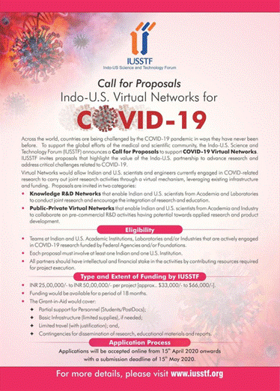

Source
Press Information Bureau, 13 April 2020

