Women in Hoshiarpur district of Punjab prepare homemade masks for villagers to fight COVD 19
In GugwaalHaarvillage situated in Hajipur Block of District Hoshiarpur, Punjab, a group of young women, are working tirelessly to safeguard their residents of their village and those in the vicinity, vulnerable migrant workers and ration and food supply distributors from COVID 19 infections by making and distributing face masks free of cost. The group is led by the village Sarpanch Sh Narinder Singh.
The Punjab State S&T Council (PSCST) Chandigarh supported by the Department of Science & Technology (DST) under the societal programme for women which works on‘Technological Empowerment Of Women On Energy From Rural Biomass’ being implemented in the Talwara block of district Hoshiarpur has launched a project under initiatives for the community in the scenario of Pandemic COVID-19.
"The crowd sourcing of home-made masks for the general population is fast catching up as the awareness about the mask making and its use, aided by the local leadership, has become widespread. This will prove to be a vital action in slowing and breaking the chain of transmission,” said Professor Ashutosh Sharma, Secretary, DST.
The initiative started on 6 April 2020 as the women participated stitching and making homemade cloth masks as per the instructions issued in the manual released by the office of Principal Scientific Adviser to the Government of India. PSCST supported this group by providing necessary raw material for this noble initiative.Within ten days, the group of women supplied more than 2000 good quality masks in four villages near GugwaalHaar to migrant labour, villagers, small-time shopkeepers.
Further, PSCST has also created a Whatsapp Group for Sarpanches, local SHGs, women & adopted farmers from about 30 villages of Talwara Block. The members of Whatsapp group are being sensitized about the various advisories being issued by State/Central Government. The local population has welcomed the initiative, and sarpanches of these villages are ensuring that people adhere to guidelines issued by the Government from time to time.
For more details: Dr InduPuri, Scientists ‘F’, DST, indub.puri@nic.in, Mob: 9810557964
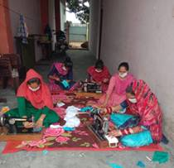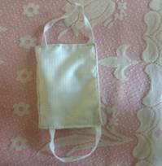
Fig: Glimpses of activities being carried out by the Group
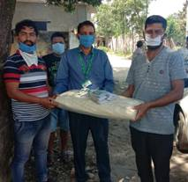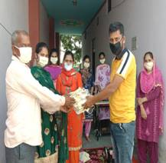
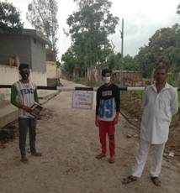

Source
Press Information Bureau, 15 April 2020

