CSIR-CMERI comes up with High Flow Rate Water Purification Technology for Fluoride and Iron Removal

By: Prof. (Dr) Harish Hirani & Dr. Priyabrata Banerjee

NEED OF THE TECHNOLOGY:

The contamination of fluoride and iron in drinking water is increasing day by day. Iron is the most abundant trace element in human body, responsible for accomplishment of vital biological functions such as gastrointestinal processes and the regulation of body temperature. But when iron level in water is beyond 0.3 ppm (as per WHO guideline), it shows several adverse effects including liver disease, irregular heart rhythm and neuronal disorder etc.

Similarly, restricted dose of fluoride ( less than 1.5 ppm, as per WHO guideline) in drinking water is required for proper strengthening of teeth and bones in human body. But intake of excess fluoride can affect human health profusely by causing dental and skeletal fluorosis initially, which leads to a crippling malady in the long run. About 60-70 million people of India have been indicated to be at excess (fluoride) F– threat. According to the report by Ministry of Drinking Water and Sanitation, the groundwater in more than ten thousand five hundred rural habitations distributed in various states of India are found to be contaminated with elevated fluoride concentration. Therefore, there is a need of affordable water purification technology for fluoride and iron removal.

CSIR-CMERI for the very first time has come up with a dual solution (excess F⁻ and Fe³⁺ mitigation from ground water). The present invention reveals about proper design and subsequent development of an integrated, low-cost, commonly available multi-adsorbent based community level (high flow rate) water purification system for effective and simultaneous removal of fluoride and iron (below WHO permissible limit) in an efficient manner from contaminated water.

SUMMARY OF THE INVENTION:
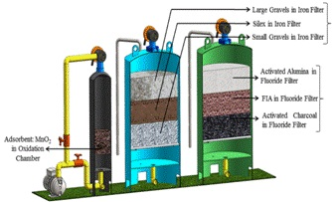
The present invention relates to an integrated approach towards design and development of a community level water treatment plant with high flow rate (10,000 litre/hr) to remove fluoride and iron from contaminated water bodies and the process thereof.
Three FRP (Fibre Reinforced Plastic) made vessels of specific dimensions has been set up here in series with each other, which are: i) Chamber-I (oxidation chamber), ii) Chamber-II (Iron removing filter) and iii) Chamber-III (Fluoride removing filter). The oxidation chamber contains manganese oxide enriched ores within the permissible limit, which act as an oxidising agent (screens out metal contaminants like Fe²⁺). The Iron removal filter contains naturally abundant lowcost adsorbent materials such as gravels and treated sand of specific diameter.

Lastly, the Fluoride removal filter also contains several low cost adsorbent materials viz. activated alumina, ferrite impregnated activated alumina (FIA, a patented product from CMERI) and zinc impregnated activated charcoal (patented product from CMERI) in sequential manner to mitigate the residual fluoride from groundwater. A hypochlorite dosing pump with dosing in proper proportions and micron filter are installed in line with the mentioned vessels for disinfection of targeted contaminated water. Hypochlorite is used in permissible range in place of chlorine gas for safety reasons. To meet the high demand of fluoride free cost effective drinking water focus was to achieve 10,000-12,000 litre/hour flow rate of the purified water. The flow is being continuously monitored by installing a flow meter. The developed plant is successfully able to mitigate iron from an initial concentration of ~9 ppm to less than 0.3 ppm (safe limit of Fe as per WHO guideline) and fluoride from initial ~12 ppm to <1.5 ppm (safe limit of F⁻ as per WHO guideline).

WORKING PRINCIPLE:

The CSIR-CMERI developed Fluoride and Iron removal system is comprised of three staged purification system. The first FRP make vessel (Chamber-I)is for rapid removal of precipitated iron. The next one(Chamber-II) is one of the most crucial chambers for removal of the left over iron from the contaminated water.In final stage fluoride will be removed from contaminated ground water by ‘fluoride removal unit’ (Chamber-III), where the adsorbents will fulfil the purpose of fluoride mitigation.

UNIQUENESS OF THE PRESENT PLANT:
- An initiative towards solving dual contaminants problem in ground water (F⁻ as well as Fe³⁺)
- An integrated adsorbent based water purification system for effective removal of fluoride as well as iron in an efficient manner from contaminated water bodies.
- High flow rate (10,000 litres/h) integrated purification system.
- Sustainability towards healthy livelihood generation.
- Selective backwash without dismantling any part of the plant.

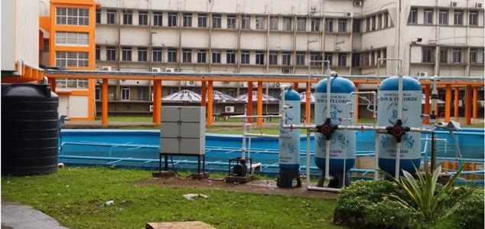
High Flow Rate Iron and Fluoride Removal Filter Plant (Model – I)

[Authors:
Prof. (Dr) Harish Hirani is the Director, CSIR-CMERI, Durgapur (WB)
And Dr. Priyabrata Banerjee is Principal Scientist, Department of Surface Engineering and Tribology, CSIR-CMERI, Durgapur (WB)]

Source
Press Information Bureau, 09 October, 2020

