Dr. Harsh Vardhan launches “CSIR Floriculture Mission”

Dr Harsh Vardhan exhorts scientists of CSIR laboratories across the country to develop models at each laboratory under the “CSIR Floriculture Mission”
Floriculture can give 5 times more return than the traditional crops to farmers besides having potential to provide employment to a large number of people: Dr. Harsh Vardhan
Also launches“CSIR’s Societal Portal along with the Android App” to facilitate public to submit societal problems that can be resolved using S&T interventions
Dr Harsh Vardhan today exhorted scientists of CSIR laboratories across the country to develop the land available at each laboratory to be set up as a model under the “CSIR Floriculture Mission”. Recently, CSIR Floriculture Mission has been approved for implementation in 21 States and Union Territories of India wherein available knowledgebase in CSIR Institutes will be utilized and leveraged to help Indian farmers and industry re-position itself to meet the import requirements. The Minister was addressing the gathering at the launch of “CSIR Floriculture Mission” through virtual mode in New Delhi today.

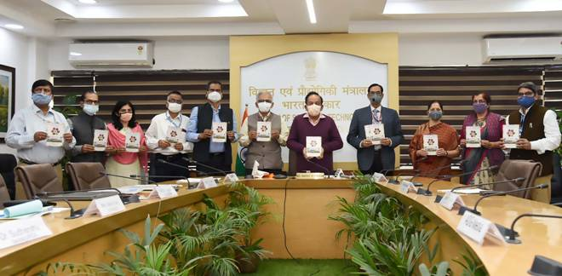
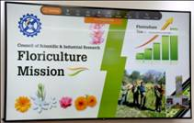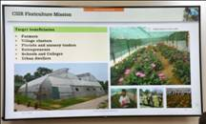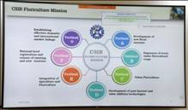
This Mission is being implemented in collaboration with Indian Council of Agricultural Research (ICAR)-Directorate of Floriculture; Khadi and Village Industries Commission (KVIC); Agricultural and Processed Food Products Export Development Authority (APEDA), Ministry of Commerce; Tribal Cooperative Marketing Development Federation of India Ltd. (TRIFED); Fragrance and Flavour Development Centre (FFDC), Kannauj, Ministry of Micro, Small and Medium Enterprises (MSME) and Universities.
Dr. Harsh Vardhan said, “Farmers have little knowledge about floriculture which can give 5 times more return than the traditional crops. Floriculture has the potential to provide employment to a large number of people through nursery raising, floriculture farming, entrepreneurship development for nursery trade, value addition and export”. The Minister pointed out, “Despite the fact that India has diverse agro-climatic and edaphic conditions, and rich plant diversity, it shares only 0.6 % of global floriculture market. At least 1200 million USD worth of floriculture products are being imported by India every year from different countries”.
Dr. Harsh Vardhan highlighted,“Since 1953, CSIR has been developing new floral varieties and several value addition technologies. Through Floriculture Mission of CSIR, agro-technologies, new varieties and value addition technologies available with the CSIR institutions, efforts are being made to take these to farmers and entrepreneurs, and help them in multiplying their income”. “Market linkage and trade issues will be solved with partnership of APEDA, state horticulture departments and TRIFED”, he added. The convergence of Floriculture with Apiculture as envisaged in the mission will yield even greater benefits.
The CSIR Floriculture Mission is expected to create opportunity for entrepreneurship development in floriculture . Infusion of latest technologies in the field of floriculture can be successfully led by CSIR. The mission will focus on commercial floral crops, seasonal/annual crops, wild ornaments and cultivation of flower crops for honey bee rearing. Some of the popular crops include Gladiolus, Canna, Carnation, Chrysanthemum, Gerbera, Lilium, Marigold, Rose, Tuberose etc. The Indian floriculture market was worth Rs 15700 cr in 2018. The marketis projected to reach Rs47200 cr by 2024 during 2019-24.
Dr. Harsh Vardhan also launched CSIR’s Societal Portal along with the Android App.This portal has been developed by CSIR Team with the help of MyGov Team. The Portal is to facilitate the public to submit the societal problems that can be resolved using S&T interventions. This is the first step in terms of seeking inputs on challenges and problems being faced by different stake holders in society.
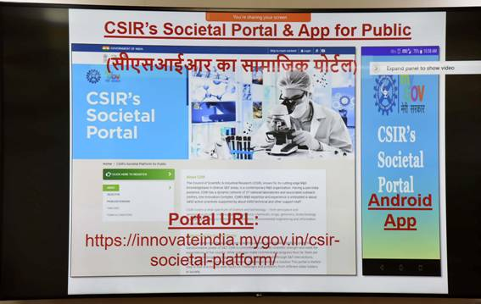
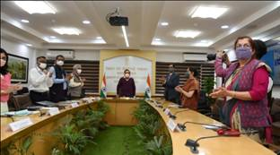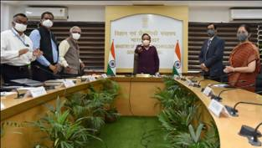
The Minister asked the scientists to make it more people centric, solution science portal, accessible to all. Dr. Harsh Vardhan said that this portal should be the most-sought-after portal for people to express their problems and seek scientific solution to them.
Shekhar C. Mande, DG-CSIR and Secretary DSIR; Dr.TrilochanMohapatra, Secretary DARE, and DG, ICAR;Prof. S. K.Barik, Director, CSIR-NBRI, Lucknow;Dr.Vibha Malhotra Sawhney, Head, TMD-SeMI, CSIR; were present on the occasion while scientists and officials from various laboratories of CSIR, representatives and officials from KVIC, ICAR-Directorate of Floriculture; APEDA, Ministry of Commerce; TRIFED; FFDC, Kannauj, Ministry of Micro, Small and Medium Enterprises (MSME) and Universities joined the event online.
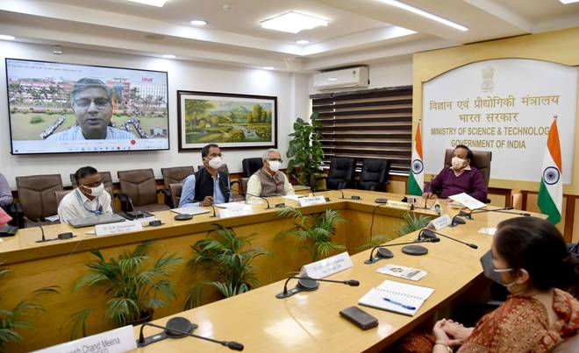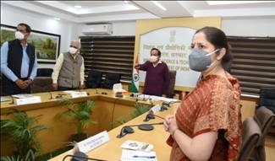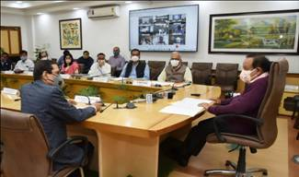

Source
Press Information Bureau, 04 March, 2021

