CSIR and Atal Innovation Mission sign a Letter of Intent to Foster Innovation in the Country

CSIR a premier R&D organization with focus on science and technology that enables innovation-driven industry and nurture transdisciplinary leadership has come together with Atal Innovation Mission (AIM), a GoIflagship initiative to promote a culture of innovation and entrepreneurship have come together to collaborate in areas of mutual interest. Towards promoting innovation in the country in various sectors, a letter of intent was signed today between the two organizations, in presence of Dr Rajiv Kumar, Vice Chairperson, Niti Aayog, Shri Amitabh Kant, CEO of Niti Aayog and Dr Shekhar C Mande, DG CSIR and other senior officials from both the organizations.

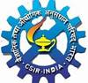
Major areas of mutual interest, among others include:
- Supporting world class start-ups through CSIR Incubators under Atal Innovation mission initiatives and jointly work on new models of innovation, including setting up of CSIR Innovation Parks. CSIR with its strong patent portfolio and knowledge base and world class researchers and AIM that has been working on policies for fostering innovation in different sectors of the economy together can boost and strengthen innovation ecosystem of the country.

- Stimulating innovation and research in the MSME industry by CSIR in collaboration with ARISE. In this context, while ARISE initiative of AIM, works to stimulate innovation and research in the MSME industry, CSIR has been working very closely with MSME where in many of its technologies and know-how have supported the MSME industry. Together they have the potential to transform and stimulate the MSME sector in the country.

- Creating problem solving mind-set across schools in India through close cooperation between Atal Tinkering Labs and Jigyasa. There is natural synergy between Atal Tinkering Laboratories that have been working to foster curiosity, creativity and imagination in young minds and CSIRs ´JIGYASA’ a Student-Scientist connect program where in >3 lakhs students across the country have been exposed to science and technology. The coming together of the two will enhance the opportunities for students and stimulate their scientific thinking and temperament.

- The joint initiatives and collaboration will be implemented through development of Work Plans, which describe specifically the activities to be carried out under this collaboration.

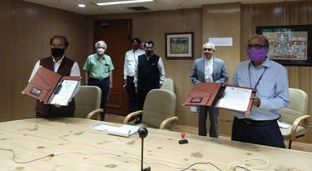

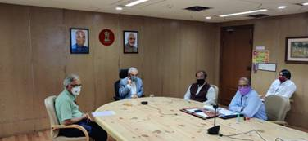

Source
Press Information Bureau, 05 June, 2020

