Dr Harsh Vardhan virtually addresses the Curtain Raiser function of IISF 2020 organised by Defence Institute of High Altitude of DRDO , Ladakh

“DIHAR has been chosen for the event due to its unique contributions to the region of Ladakh in improving living conditions of local population and soldiers through scientific development and also for contributing to military civil fusion in this strategically located area”: Dr. Harsh Vardhan
IISF-2020 being organised at a Virtual platform signifies the indomitable spirit of nurturing and celebrating scientific temperament amongst all the stakeholders of Science, Technology and Innovation: Dr. Harsh Vardhan
”The theme for IISF-2020: ‘Science for Self-Reliant India and Global Welfare’ is very relevant in present context when nation is looking towards Science & Technology for accelerating growth and for spearheading vision of Atmanirbhar Bharat” : Dr. Harsh Vardhan
“S & T become more relevant in Ladakh like region, where the prevailing harsh environment throws great challenge for sustenance of humans and animal: Lt Governor of Ladakh UT,Shri R K Mathur
Dr. Harsh Vardhan, Union Minister of Science & Technology, Earth Sciences and Health & family Welfare has said that organising the India International Science Festival -2020 this year on a virtual platform due to COVID-19, signifies the indomitable spirit of nurturing and celebrating scientific temperament amongst all the stakeholders of Science, Technology and Innovation. He was addressing the audience through video-conferencing as the Chief Guest at the Curtain Raiser function of IISF-2020 organised by the Defence Institute of High Altitude Research (DIHAR) of the Defence Research and Development Organisation (DRDO), Ladakh.

Among the participants in the virtual function included Shri R K Mathur, Lt Governor, UT Ladakh; Shri JamyangTsering Namgyal, Member of Parliament, Ladakh; Shri TashiGyalson, Chief Executive Councilor, LAHDC, Leh, Ladakh; Dr G Satheesh Reddy, Secretary, DD R&D and Chairman DRDO; Dr OP Chaurasia, Director DIHAR , Leh; Dr AK Singh, DS & DG (LS) DRDO.
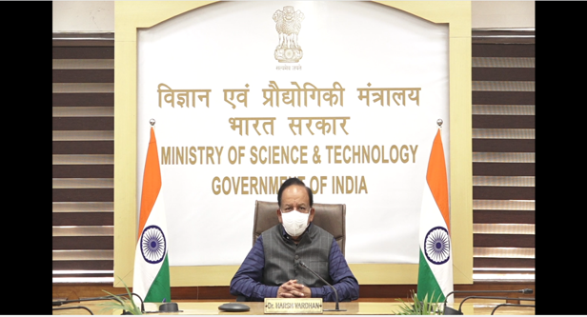

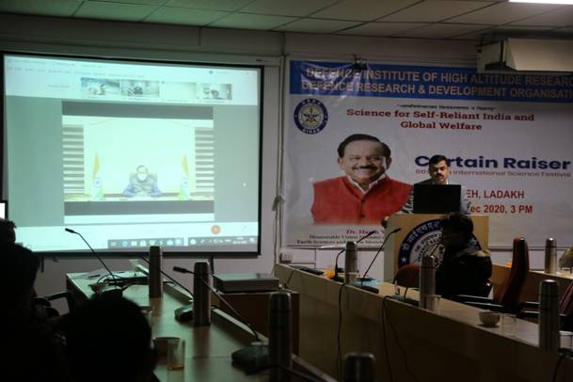

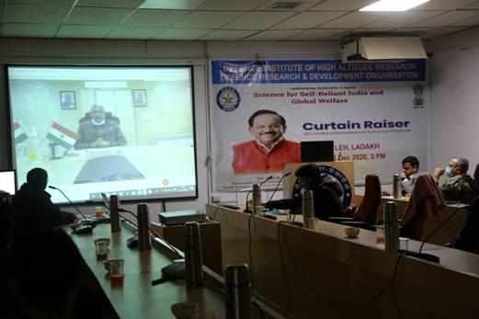

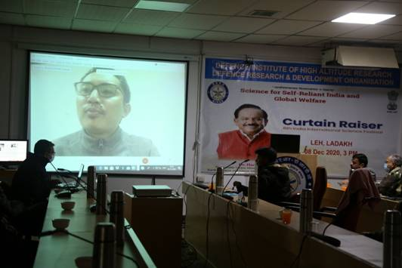

Dr. Harsh Vardhan expressed the hope that “with use of digital platform, IISF will be able to bring together people from the remotest corners of the country in a single click, thereby helping in fulfilling the objectives of organising IISF”. Wishing all the stake holders of science and technology and allied organizations who are part of this festival a grand success, the Minister said, “The IISF-2020 proposes to bring more than 10,000 researchers, scientists and experts from different subjects to discuss their research findings and exchange innovative ideas on the identified research themes”.
Dr. Harsh Vardhan explained,”The theme for IISF-2020: ‘Science for Self-Reliant India and Global Welfare’ is very relevant in present context when nation is looking towards Science & Technology for accelerating growth and for spearheading the vision of an ‘Atmanirbhar Bharat’.” He said, “IISF is a much-awaited annual event for students and science loving citizens from all spheres of life”.
“The Defence Institute of High Altitude Research i.e. DIHAR of DRDO located at Leh at an altitude of 11500 ft has been chosen for the event due to its unique contributions to the region of Ladakh in improving the living conditions of local population and soldiers through scientific development and also for contributing to military civil fusion in this strategically located area”, Dr. Harsh Vardhan expressed his happiness “Today farmers in Ladakh are growing varieties of fruits and vegetables in the uncongenial terrain, which was not possible few decades back”. “The contributions of the Institute are true reflection of the power of science and technology to bring changes at grass root level. In my opinion, organisers of the IISF-2020 have made the right selection of the venue for launch of the curtain raiser of this upcoming festival. The work being carried by the institute truly matches with the goal of the event”, he noted with satisfaction. He said, “I have great satisfaction that one of the curtain raisers in the series is being organised at newly established Union Territory of Ladakh”.
Lt Governor of Ladakh UT, Shri R K Mathur in his address, briefed about the role of Science & Technology to improve the socio-economic standard of population as well as its inherent capacity to reach every corner of our country, irrespective of challenging physical boundaries. “This becomes more relevant in Ladakh like region, where the prevailing harsh environment throws great challenge for sustenance of humans and animals. S&T has immensely helped to make livelihood in Ladakh more comfortable for the general public and remunerative for the local farmers, for which contribution of DIHAR is commendable”. He also briefed about the huge potential to exploit renewable energy sources of Ladakh to make the region self sustainable with zero carbon emission.
Shri JamyangTsering Namgyal, MP Ladakh, in his address, spoke about contributions made by DIHAR by developing suitable technologies to increase the availability of vegetable diversity in Ladakh. Endeavors like this, utilizing the potential of S&T have to be disseminated in various other domains and far flung locations, he said.
Dr AK Singh, DS &DG (LS) DRDOtalked about the importance of taking science out of R&D premises to the actual field locations so that livelihood of the population is made healthier, economical and sustainable. He further emphasized upon strengthening S&T to find local solutions to the prevailing local problems.
Dr. OP Chaurasia, Director, DIHAR and overall coordinator of this event at Leh, in his welcome address, mentioned about the importance of organizing such an event in remote location of Ladakh and he pledged to disseminate the developed technologies among the masses in this high altitude region of Ladakh.
The event witnessed participation via online media from diverse areas like administration, policy, education, agriculture, entrepreneurship and students.
Established in 1960, DIHAR has developed regionally suited agro-animal technologies for the unique terrain and climatic conditions. The institute continues to carry on the good work to fuse economic and social development strategies for local populace with security strategies for the country to build an integrated national strategic system and capabilities in support of national rejuvenation goals which is the need of the day. DIHAR under the aegis of DRDO endeavours to strengthen food, health and energy security of the troops deployed in high Himalayas through scientific innovations, transfer of technologies and involvement of the local population to augment the availability of fresh food for the army. Over the years, DIHAR has evolved as a doyen of high altitude research and pioneered the development of the cold arid agro-animal technologies for high altitude to ensure sustenance and enhancing the performance of troops guarding the northern frontiers.
The 6th India International Science Festival (IISF)-2020 is being organised from 22 to 25 December 2020 in virtual mode. It is in this context that a series of curtain raisers are being organised in different regions of country so that maximum population can benefit from the event.
This is the largest science festival on virtual platform. This year, 41 events will be organized under 9 verticals. This year IISF 2020 is attempting entries inGuinness World Recordsunder five different categories. The registration is open for 33 events out of 41 events. The participation in the overseas ministers and diplomats’ conclave, state S&T conclave, science education in India and Guinness World Records will be through nominations and direct invitation. The other events will have open registrations. The registrations can be done through the IISF 2020 website https://www.scienceindiafest.org/#/home

Source
Press Information Bureau, 8 December, 2020

