Aarogyapath, a web-based solution for the healthcare supply chain that provides real-time availability of critical supplies launched

A CSIR National Healthcare Supply Chain Portal that aims to provide real-time availability of critical healthcare supplies https://www.aarogyapath.inhas been launched on June 12,2020. AarogyaPath would serve manufacturers, suppliers and customers. During the present national health emergency arising out of the COVID-19 pandemic, where in there is severe disruption in supply chain,the ability to produce and deliver the critical items may be compromised due to a variety of reasons. The information platform named AarogyaPath with a vision of “providing a path which leads one on a journey towards Aarogya (healthy life)” was developed to address these challenges.

This integrated public platform that provides single-point availability of key healthcare goodscan be helpful to customers in tackling a number of routinely experienced issues. These issues include dependence on limited suppliers, time-consuming processes to identify good quality products, limited access to suppliers who can supply standardized products at reasonable prices within desired timelines, lack of awareness about the latest product launches, etc.

It also helps manufacturers and suppliers to reach a wide network of customers efficiently, overcoming gaps in connectivity between them and potential demand centers like nearby pathological laboratories, medical stores, hospitals, etc. It will also create opportunities for business expansion due to an expanded slate of buyers and visibility of new requirements for products. Over time, analytics from this platform is expected to generate early signals to manufacturers on over capacity as well as on looming shortages. This would help to reduce wastage of resources due to inefficient forecasting and excess manufacturing, generate awareness about the demand for new technologies.

CSIR expects AarogyaPath to become the national healthcare information platform of choice in the years to come, filling a critical gap in last-mile delivery of patient care within India through improved availability and affordability of healthcare supplies.

It was launched by Shri Rajesh Bhushan Officer on Special Duty, Ministry of Health and Family Welfare in presence of DG CSIR, Dr Shekhar C. Mande. Shri Sudhir Garg Joint Secretary, Ministry of MSME and Dr. Vijay Chauthiawale Pharma Sector Expert were guests of honour at this event. Dr Shekhar Mande complemented the CSIR team involved in development of the portal, which was led by Dr Anjan Ray, Director CSIR-IIP. The portal was developed in partnership with Sarvodaya Infotech and institutional users and manufacturers / authorized suppliers of healthcare essentials are encouraged to register and participate actively.
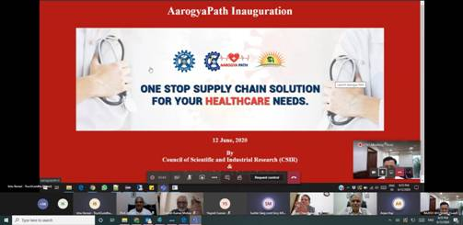

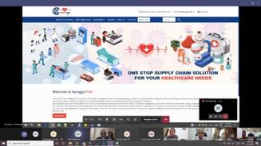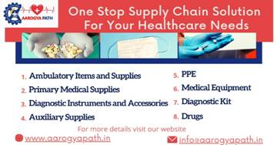

Source
Press Information Bureau, 13 June, 2020

